1. Given the provided data, what are three conclusions we can draw about Kickstarter campaigns?

* According to Category Based Pivot Table, the most common project category in Kickstarter is theater, with almost 1400 (1393) projects. Theater category also has almost half of the total percentage of successful projects, which could lead us to think that if we are trying to enter Kickstarter with a project, it would be a good idea to choose theater as category. (See Fig. 1)
* On the other hand, analyzing successful state proportion for Category (See Fig. 2), the category that has the biggest proportion of successful projects (within a Category), is music (17% of the total) with 13% out 17% percent, almost 75% of the music projects see themselves successful, so if we are talented enough, it is definitely a good idea to start a music project and let it be supported in Kickstarter.
* Last, and according to Fig. 2., the least supported projects come from Journalism, as they saw no successful projects, so it is definitely not recommended to start a journalism project.
* In Fig. 3., we can observe that the success rate drops in the last two months of the year (November-December). With the last we can propose that in the last months of the year, the people are less willing to support projects, as probably they are ready to spend a lot for the Holidays, so it is a good idea to avoid these dates.
* By the same idea of the last point, the best dates to start a project is definitely between April and May, probably because people are recovering economically.

1. What are some limitations of this dataset?

* The data is historically old, from 4 years ago, so we could conclude on several things, but trends way move too fast and our conclusions will be surely outdated. It would be great to have more recent data.
* We have above 4000 records, it is a good number of records, but how do we know that this sample of data represent the whole population and it is not biased.
* When filtering through country, a big proportion corresponds to United States data. Obviously Kickstarter is way bigger in US than in any other country and the support definitely comes more from here than from any other country, but if we propose something that does not match with US trends, we could be in trouble.

1. What are some other possible tables and/or graphs that we could create?

I suggest we could create a Pivot Table which rows are the years from 2009-2017 (records from the projects) and the columns are the different categories present in the data. And the values we are visualizing are the sum of the pledged amount for the projects. So, we are going to visualize how much money was pledged for category each year. We can add a filter for currency if we just want to visualize USD and do not mix currencies. We will end with something as the following.

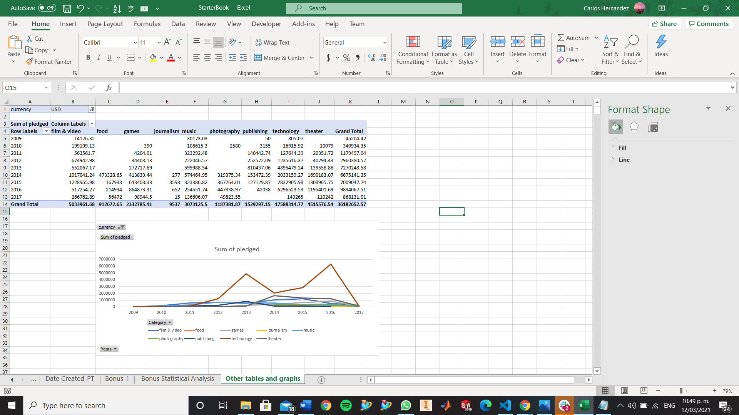

Fig. Other tables and graphs 1.

Next, we can also add a Pivot Table with Currency as rows, Category as columns and values as Count of Projects. In this case, we will be able to visualize how many projects are there for each currency per category. This gives us an idea of what Category is more popular per country (and which countries have information of Kickstarter).

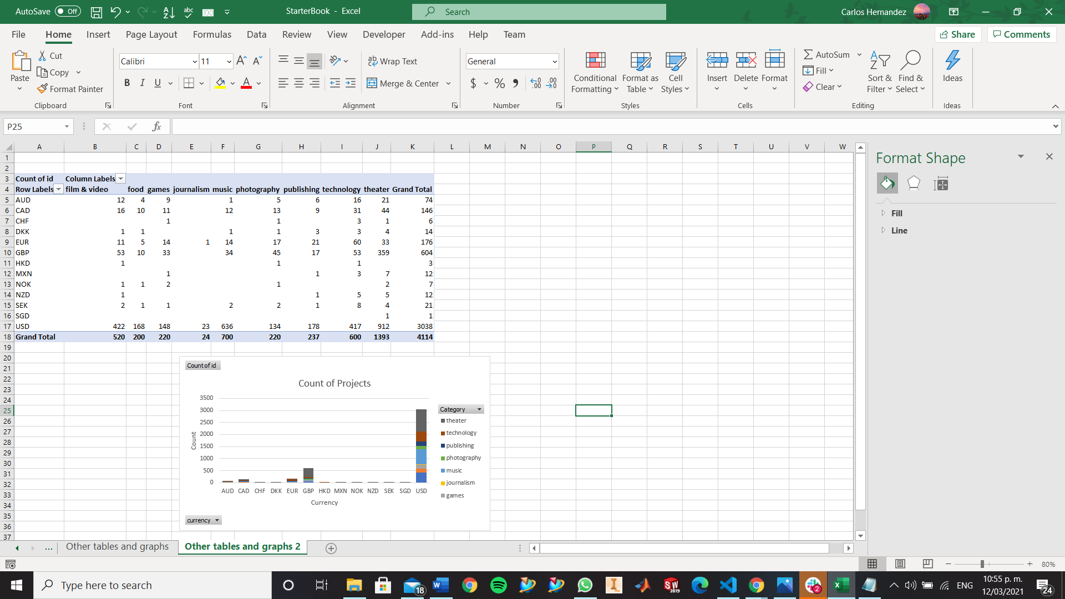

Fig. Other tables and graphs 2.

Figures.

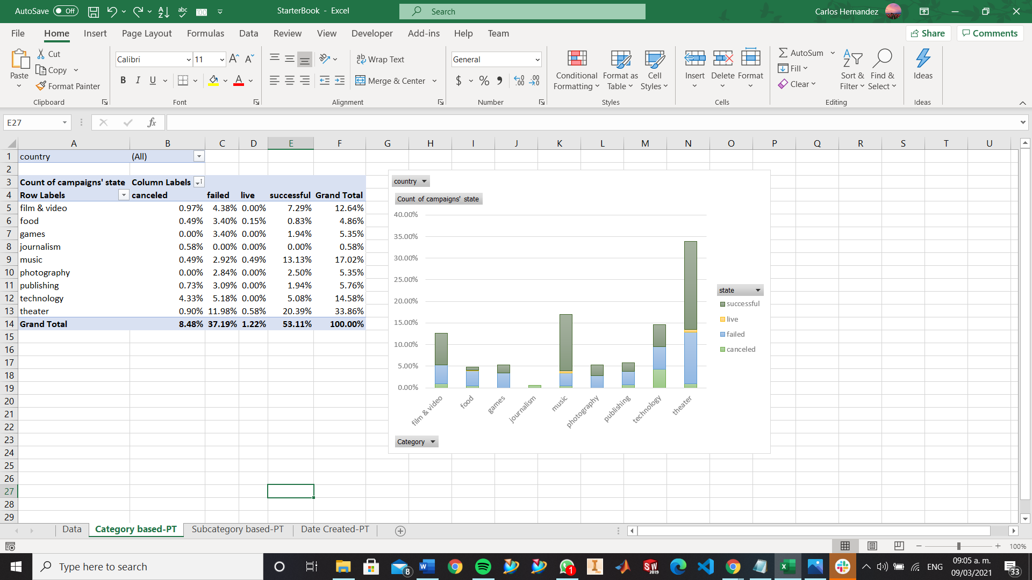

Fig. 1.

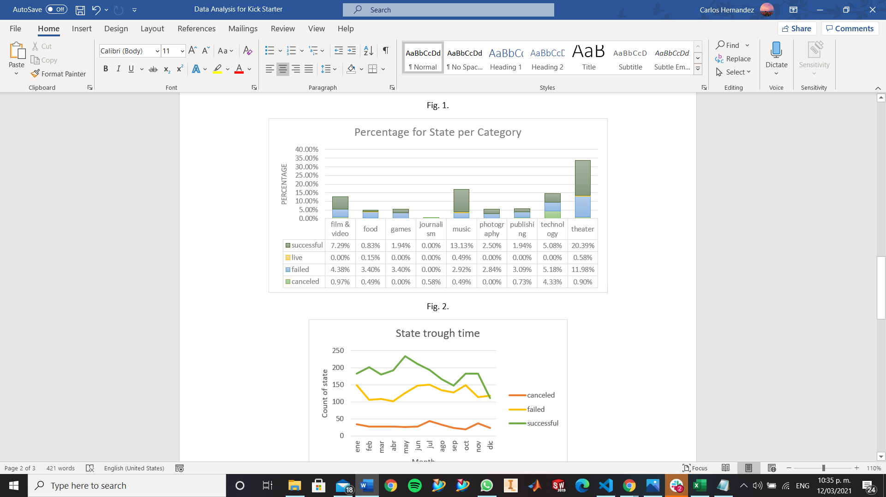

Fig. 2.

Fig. 3.